* 1. General Information
     1. Design Code : IS456:2000
     2. Unit System : N, mm
  2. Material
     1. : 25.00MPa
     2. : 415MPa
  3. Design Load
     1. Dead Load : 2.000kN/m²
     2. Live Load : 2.000kN/m²
  4. Section Size
     1. Span(X) : 4.000m
     2. Span(Y) : 6.000m
     3. Thickness : 201mm
     4. Cover : 20.00mm
     5. Use clear span : Yes

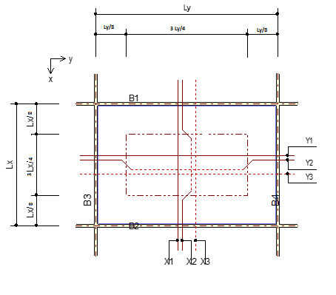

* 1. Slab Type & Support
     1. Slab Type : 2-Way Slab
     2. Support Type : Case-2
     3. Boundary Beams (mm)
        + B1 : 100 x 200 B2 : 100 x 200
        + B3 : 100 x 200 B4 : 100 x 200
  2. Check Load
     1. Calculate factored load **[IS456:2000 Table 18]** 
        + LCB = 8.400kN/m² ( 1.5D+1.5L )
        + 5.600kN/m²
  3. Check Thickness of Slab
     1. Calculate factors
     2. Calculate minimum thickness required **[IS456:2000 24.1]**
        + 200mm
  4. Check Capacity of Slab
     1. Calculate Moment & Shear [ Direction X ]

|  |  |  |  |
| --- | --- | --- | --- |
| **Check Items** | **TOP** | **MIDDLE** | **BOTTOM** |
| Bar-1 | P5@450 | P5@450 | P5@450 |
| Bar-2 | P5@450 | P5@450 | P5@450 |
| Bar-3 | P5@450 | P5@450 | P5@450 |
| Moment Coefficient | 0.0763 | 0.000 | 0.0763 |
| Shear Coefficient | 0.841 | 0.000 | 0.841 |
|  | 6.502 | 3.689 | 6.502 |
|  | 9.186 | 0.000 | 9.186 |
|  | 52.59 | 52.59 | 52.59 |
|  | 108 | 108 | 108 |
|  | OK(0.124) | OK(0.0701) | OK(0.124) |
|  | OK(0.0850) | OK(0.000) | OK(0.0850) |

* + 1. Calculate Moment & Shear [ Direction Y ]

|  |  |  |  |
| --- | --- | --- | --- |
| **Check Items** | **LEFT** | **CENTER** | **RIGHT** |
| Bar-1 | P5@450 | P5@450 | P5@450 |
| Bar-2 | P5@450 | P5@450 | P5@450 |
| Bar-3 | P5@450 | P5@450 | P5@450 |
| Moment Coefficient | 0.0147 | 0.000 | 0.0147 |
| Shear Coefficient | 0.159 | 0.000 | 0.159 |
|  | 2.858 | 1.683 | 2.858 |
|  | 2.623 | 0.000 | 2.623 |
|  | 47.51 | 47.51 | 47.51 |
|  | 98.18 | 98.18 | 98.18 |
|  | OK(0.0601) | OK(0.0354) | OK(0.0601) |
|  | OK(0.0267) | OK(0.000) | OK(0.0267) |

* 1. Corner Reinforcement
     1. Discontineous on both side **[IS456:2000 Annex D-1.8]**
        + As = 0.75 * Ast = 230 mm2

Provide Length at corners (Both in X and Y, at top and Bottom)

* + - * Lx/5 = 800 mm
    1. Discontineous on One side **[IS456:2000 Annex D-1.8]**
       - As = 0.375 * Ast = 115 mm2
    2. Provide Length at corners (Both in X and Y, at top and Bottom)
       - Lx/5 = 800 mm